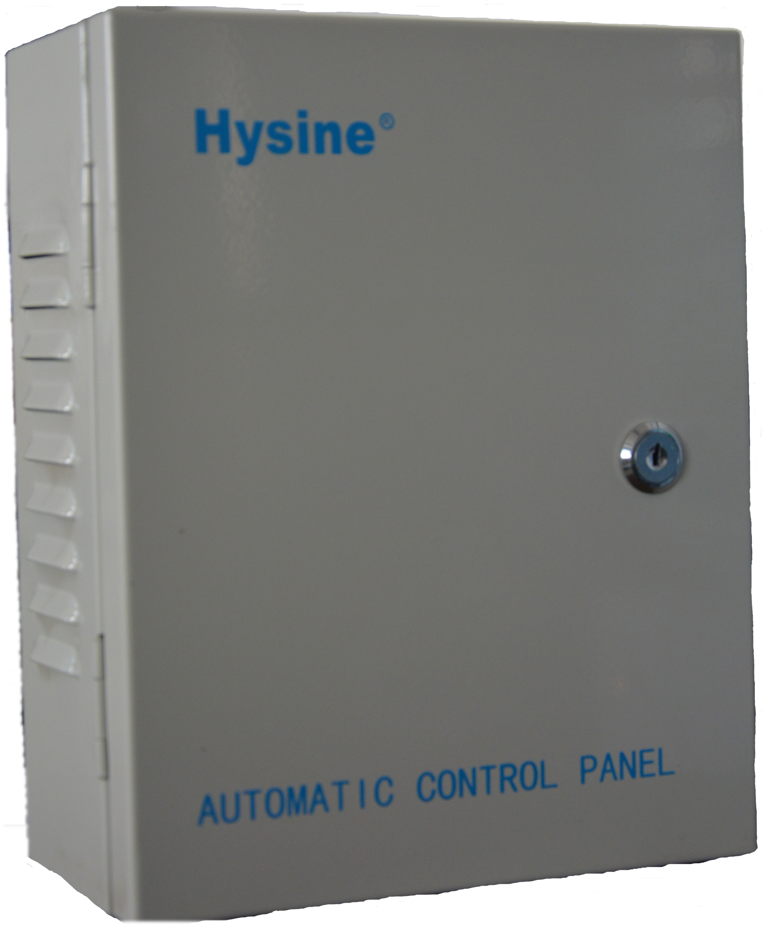
RH-3I-E-N10
External Temperature Sensor

Features
• external temperature measurement.
• Variable Thermistors，PT or NI sensing elements to fit your system
• Simple and secure installation

Applications
• Indoor air temperature sensor for comfort control
• Frost protection sensor

Temperature Sensor
The sensor measures the temperature by use of a NTC, PT or NI sensing element. The sensing element is either a glass packed thermistor with a negative temperature coefficient or a platinum film sensor or a thin nickel layer on a ceramic substrate. Its resistance changes according to the temperature. The change follows a specified curve. Below is a list of available sensor elements, curves and accuracies:

Item name | Sensing element | Curve | Compatible with
N18 | Thermistor 1.8k at 25 °C | Curve 5 | TAC, CSI
N3 | Thermistor 3k at 25 °C | Curve 6 | Alerton
N10 | Thermistor 10k at 25 °C | Curve 24 | Hysine, Alerton,ALC, Delta,Trane, CSI
N11 | Thermistor 10k at 25 °C | Curve 7 | Andover, Invensys, Carrier, KMC
N20 | Thermistor 20k at 25 °C | Curve 20 | Honeywell
N100 | Thermistor 100k at 25 °C | Curve 9 | Siemens SBT
Tp1 | PT100 | 0.3851ohm/K | Honeywell
Tp2 | PT1000 | 3.851ohm/K | Johnson Control
TK5 | NI1000 | 5000ppm/k | Siemens SBT
Ordering
Ordering number:RH-3I-E-N10
XX indicates the sensor element optional，see table above.
For example: RH-3I-E-N10
-N10 indicates the sensor element is Thermistor 10k .
Construction
This sensor is constructed to high quality standards. The housing is available in different colors with RAL9003 as the standard. It is made of fire proof ABS plastic and the unobtrusive design and size will blend into any interior decoration. A metal mounting plate that fits on most commercially available recessed conduit boxes guarantees a save installation.
Installation
Mount the temperature sensor on a flat interior wall of the room to be controlled. Do avoid obstructions such as shelves, curtains and recesses. Do not place near heat sources, draft channels. Do not expose to direct sunlight.
• When installing the unit, fix the base plate first, connect the electrical connections then hook on the cover and secure it.
• The end of the conduit at the sensor must be sealed to prevent false measurements due to draughts through the conduit.
• Connect the wires according to the wiring diagram to the measuring circuit in the cover:
o The Thermistors require two conductors; normally 18ga unshielded twisted pair.
o The PT100, PT1000 and NI1000 sensors come with each two terminal connectors in order
to connect up to four conductors for compensating conductor resistance.
Technical Specification

Sensing Element | Thermistor: Range  Accuracy | NTC  -30----70°C  ±0.5k
Sensing Element | Platinum-Film: Range Accuracy | PT, 0.3851ohm/k  -30----70°C  ±0.3k
Sensing Element | Nickel Thin Layer Range Accuracy | NI, 5000 ppm/k  -30----70°C  ±1k
Connection | Connection Terminals | 2.5 mm2
Environment | Operation  Climatic Conditions Temperature Humidity | To IEC 721-3-3 class 3 K5  -40…70°C  <95% r.h.
Environment | Transport & Storage Climatic Conditions Temperature Humidity  Mechanical Conditions | To IEC 721-3-2 and IEC 721-3-1 class 3 K3 and class 1 K3  -40…80°C  <95% r.h. class 2M2
Standards | conform according to  EMC Standard 89/336/EEC EMEI Standard 73/23/EEC | EN 61 000-6-1/ EN 61 000-6-3
Standards | Automatic electrical controls for household and similar use  Special requirement on temperature dependent controls | EN 60 730 –1  EN 60 730 – 2 - 9
Standards | Pollution Class | Normal acc. To EN 60 730,RoHS compliant
Standards | Degree of Protection | IP56 to EN 60 529
Standards | Safety Class | III (IEC 60536)
Housing Materials | Cover & Mounting Plate | Fire proof ABS plastic
General | Dimensions [mm] | Cover250 x 200 x 100(H x W x D)
General | Weight (including package) | 500g
Wiring Diagram

1
2
3
4

DC24V
RH-I
NTC
NTC

Dimension [mm]
Hysine
AUTOMATIC CONTROL PANEL
100mm
250mm
200mm

